Application for Commonwealth Women’s Leadership Programme 2026/27
When completing this form, please be aware of the criteria that will be used for assessing applications:
- Evidence of support from your CGA to participate in the scheme.
- The relevance of your current role to the programme’s content and outcomes.
- Your willingness to act as a change agent, sharing new skills and knowledge with colleagues to build capacity.
- Demonstrate the need and impact of the funding on you and your sporting community
- Proficiency in written and spoken English.

APPLICANT DETAILS:
Name: | Age: | CGA:
Email: |  | Mobile:
Current Role & Organisation:
Describe your proficiency with written and spoken English
CGA CONTACT DETAILS: (Who is supporting your application? Who is your main point of contact?)
Name:
Email |  | Mobile:
Role:
Qualities

We are looking for women who are:
- Enthusiastic about their own personal development and for applying leadership learning in their own environments.
- Honest self-reflectors who are willing to take positive steps to develop and grow.
- Ready to make a difference to their communities through sport.
- Keen to support others to develop – especially, but not only, women.
- Ambitious to seek Committee / Board positions within sporting organisations and positively influence decision making.

COMMONWEALTH WOMEN LEADERS WEALTH MODEL
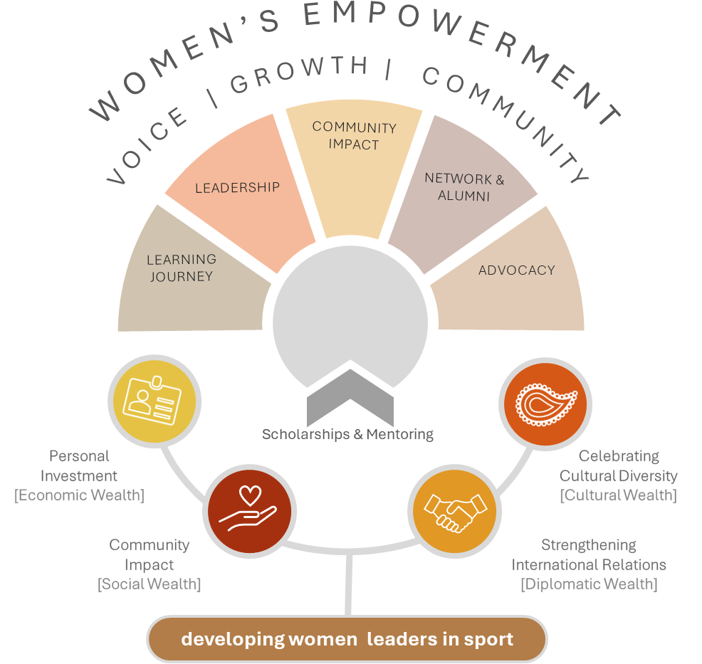
The programme’s objectives and are underpinned by five wealth’s, namely -: economic, sport, social, diplomatic, and cultural as highlighted below:

Economic Wealth
Economic wealth is generated with hosting the Games, the Commonwealth's participation, boosting local economies through increased tourism, consumer spending and local project investments and infrastructure. Employment opportunities, youth development programmes along with conferences and trade expos to promote Commonwealth nations goods and services all contribute to greater economic wealth.

Social Wealth
Social wealth is a catalyst to address and improve social issues such as inclusivity, human rights, climate change, healthy lifestyles and community development. It can promote equal opportunities and encourage participation, education, and the breaking down of social barriers that create a lasting impact contributing to a stronger, more cohesive community long after the Games have concluded.

Diplomatic Wealth
Diplomatic wealth is created through the coming together of the Commonwealth family and opportunities for building stronger international relations, political goodwill, and cooperation. It provides an opportunity for dialogue, networking, and collaborative problem-solving, aiming to forge lasting diplomatic ties and mutual understanding across diverse cultures and political landscapes.

Cultural Wealth
Cultural wealth promotes, celebrates and preserves the diverse cultural heritage of the Commonwealth at the Games and beyond. It showcases cultural performances, facilitates cultural exchanges, and highlighting the contributions of indigenous and minority cultures. An opportunity to foster mutual respect, pride, and unity among the diverse populations of the Commonwealth, creating a legacy of cultural understanding and appreciation that extends beyond the duration of the Games

Sport Wealth
Sport wealth is an integral part of societal development, contributing to social cohesion, national identity and pride, gender equality, inclusion, instilling fundamental values including tolerance, respect and understanding, health and the overall quality of life. The Games can showcase traditional sports, new sports, and create opportunities for education, community involvement and youth development.

Under each of 5 key objectives headings overleaf, explain briefly, what you are already doing and what you would like the programme to help you do more of / improve on. This might be in your paid role, voluntary roles or both.
Please complete each box and don’t worry if you have more to say in some areas than others. When answering, bear in mind the qualities we are looking for (see above).
EMPOWERMENT | Empower women in sport by providing resources to access the skills, knowledge and experiences needed to become effective leaders in their sport and communities
How do you empower yourself and others now?
How would you like to improve in this area?

LEADERSHIP | Foster the growth of leadership skills among Commonwealth women in sport through the co-creation of personalized development plans and mentorship.
What are your current leadership strengths?
What areas of leadership would you like to improve?

COMMUNITY IMPACT | Encourage participants to apply their leadership skills to make a positive impact in their communities through sports.
What impact do you currently have on your community through sports?
What impact would you like to have?

NETWORKING | Facilitate networking and collaboration among women in sport leadership roles across the Commonwealth.
What are your networking strengths?
How would you like to improve your networking skills?

ADVOCACY | Promote the importance of gender diversity and women's leadership in sports at national and international levels.
How do you currently promote gender diversity and women’s leadership?
What would you like to improve / develop in this area?

Leadership Values / Philosophy
In no more than 400 words, explain what is most important to you about being a leader. What values do you hold dear when working with others? Provide one or two examples of how you have demonstrated your leadership values.

Scholarship Fund up to a maximum of £5000
Explain as clearly as you can, what the money is needed for and what impact you believe this funding could have on your personal development and on your sporting community.
How will you ensure the money helps sustain and build beyond the 12 months of this programme?

Application Process
Please provide the following documents to Ms. Janelle Denny, Director of the National Olympic Academy, at email, janelle.denny@olympic.org.bb. or through the Barbados Olympic Association’s email, info@olympic.org.bb, by 25TH September 2026.
- Completed application form
- CGA Endorsement letter which should include
  - Confirmation of nationality of applicant
  - CGA to outline their aspirations for the applicant related to the CGA’s leadership
  - Outline why this opportunity is best for the applicant vs other opportunities that are available to them
- Current Curriculum Vitae
- Transcript or copy of relevant qualifications

